Disease Occurrence
$$Incidence Rate = \frac{new cases / population}{time}$$
$Cumulative Incidence = \frac{new cases in window}{population at risk}$
$$Point Prevalence = \frac{case count}{population}$$
$Period Prevalence = \frac{case count in time window}{average population}$
- includes pre-existing cases
$Mortality Rate = \frac{deaths / population}{time}$
$Standardized Mortality Ratio (SMR) = \frac{observed deaths}{expected deaths} × 100$
- compares observed deaths to expected deaths for a group
$$Case-Fatality = \frac{deaths}{cases}$$
$$Attack Rate = \frac{number of new cases}{number at risk}$$
Risk Tables
 | Disease | No Disease
Exposed | a | b
Not Exposed | c | d

$$Incidence of Exposed = I_{E}= \frac{a}{a+b}$$
$$Incidence of Not Exposed = I_{U}= \frac{c}{c+d}$$
$$Risk Difference (RD) = risk 1 - risk 2=I_{E}-I_{U}$$
$$Risk Ratio (RR) = \frac{risk group 1}{risk group 2}= \frac{I_{E}}{I_{U}}$$
$$Odds = \frac{P(A)}{1 - P(A)} =\frac{I_{E}}{1 -I_{E}}$$

$$Odds Ratio = \frac{I_{E}/\left(1-I_{E}\right)}{I_{U}/\left(1-I_{U}\right)}$$
- Approximates the Risk Ratio when the outcome is rare (<10%)
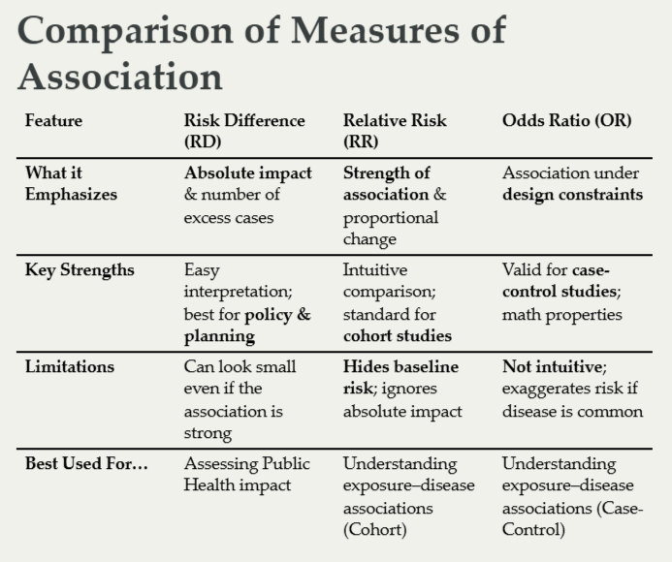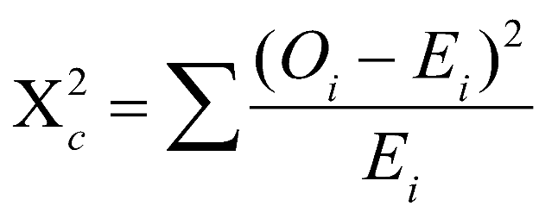
$$Z = \frac{p_{1}-p_{0}}{SE(p_{1}-p_{0})}$$
$$Var(p_{1}-p_{0}) = p(1-p)(\frac{1}{n_{1}}+\frac{1}{n_{2}})$$
- p1 is the estimated probability of the condition for group 1 and p0 is the estimated probability for group 0
- p is the overall probability of the condition across groups
$$SE(log OR) = {(\frac{1}{a}+\frac{1}{b}+\frac{1}{c}+\frac{1}{d})}^{1/2}$$
$$Wald Statistic = Z = \frac{log OR}{SE(log OR)}$$
- The Wald Statistic is another way of getting significance out of a 2x2 table, squaring it makes for the exact same thing as the chi-squared test
Fisher’s Exact Test will give you an exact p-value when a, b, c, or d are <5

Study Design
Cohort - get a bunch of people that are at risk for the disease and then follow them and see who gets it
Case-Control - start with a bunch of people who have the disease, then find healthy counterparts, then look backwards to count exposures
Nested Case-Control - like a cohort but pick counterparts like a case-control as each case occurs
Case-Crossover - each subject is their own control before the exposure as well as a case after exposure
Cross-Sectional - single point in time for a population getting exposures and cases
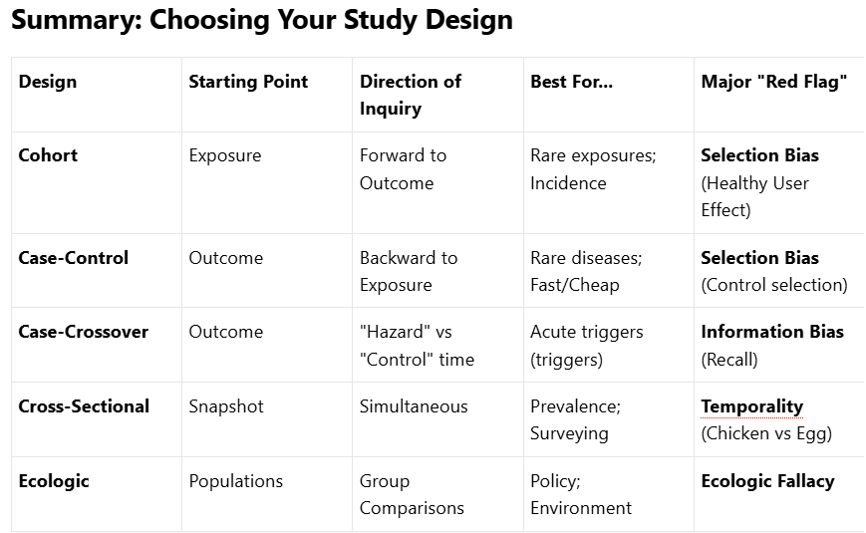
Ecologic - make large group comparisons to try and tease out exposure and case associations

Diagnostic and Screening Tests

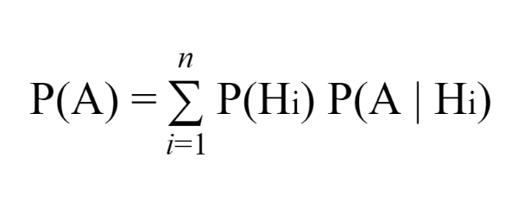
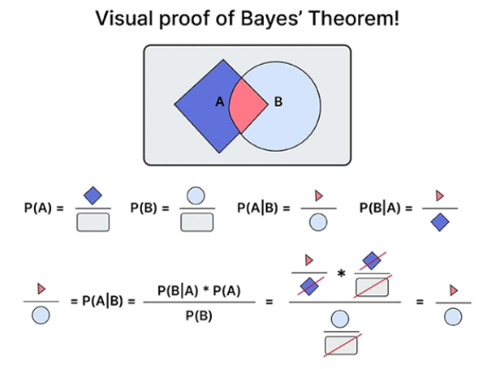
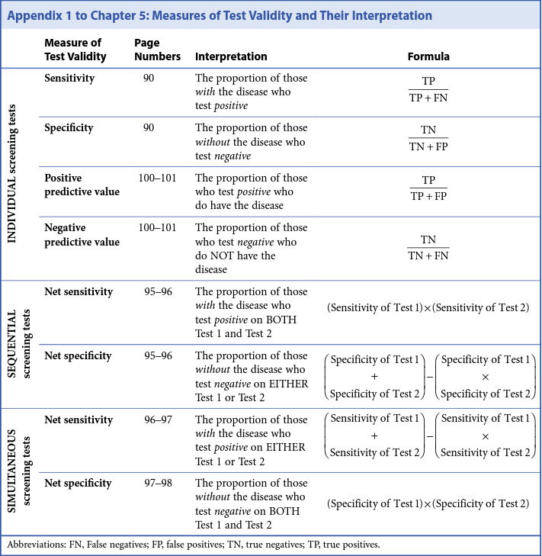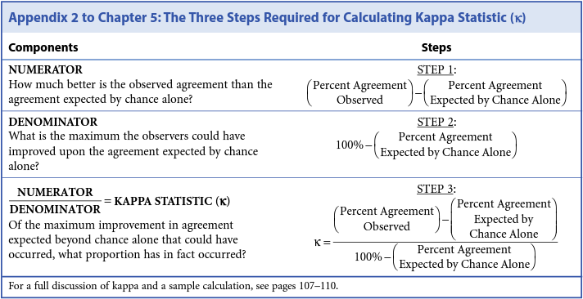

Model Evaluation
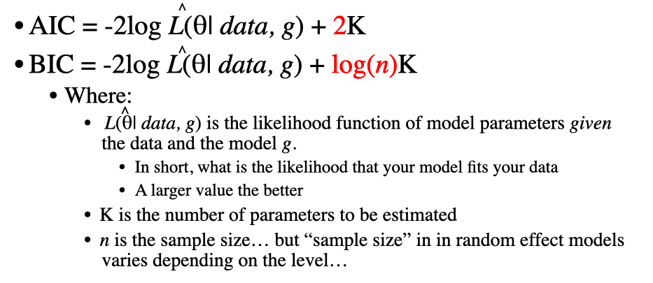
Survival Analysis
$$Density Function=\frac{d}{dt}F(t)=-\frac{d}{dt}S(t)$$
$$Survival Function =S(t) = P(T>t)=1-F(T)$$
$$Hazard Function = h(t) = \frac{event density at point}{prob survived up to that point} = \frac{f(t)}{S(t)}$$
Kaplan-Meier Curve
$$KM Survival Estimate = S(t) =\prod_{times with events}{(1-\frac{\# events at time}{\# at risk right at time})}$$
- The survival estimate changes at each timepoint with at least one event
- Multiply the survival calculated at that point with all previous event survival probabilities
- Censors may happen between events, but they only affect the number at risk for the next event time point, just mark an x or | on the chart
- Use the log-rank test to get actual significance between groups, but it only works if the lines don’t cross
- $χ^{2}=\sum_{groups}{\frac{{[\sum_{event times}{(observed events - expected events)}]}^{2}}{Variance of the goup}}$

Propensity Scores
- The propensity score is the probability of the treatment as a function of the covariate, we’re trying to balance people who got the treatment with controls that had a similar likelihood of getting the treatment
- Usually logistic regressions are used
- In the end use love plots that show the Standardized Mean Difference (SMD), we want the absolute SMDs to be less than 0.1 or at least 0.25
- Define treatment and outcome; choose estimand (ATE vs ATT).
- Choose pre-treatment covariates X guided by subject-matter knowledge and DAGs.
- Estimate propensity scores (logistic regression, machine learning).
- Check overlap of PS distributions across groups.
- Match (or weight/stratify) based on PS.
- Check covariate balance (standardized mean differences, love plots).
- Estimate causal effect in matched/weighted sample, using appropriate variance estimation.
- Sensitivity analyses for unmeasured confounding and model choices.

